How to Setup your Facebook Business Page

First of all, you should ask yourself are you really going to use Facebook to boost your business. Creating a page isn’t enough, you actually have to use it consistently to engage with your followers and you need to constantly work at growing your following.

Realistically, to do this, you should be able to dedicate at least an hour each day to social media and it will take time before you start to see the reward. It will definitely take a while before you begin to see any results from marketing through social media so if you are expecting something to be quick and easy, this is probably not for you. Always keep in mind; if you set up your business page and you don’t actually use it, then this will only do more to hurt your business than it will to help.

**Another option would be to just use your personal page or create a new personal page to use for business. However, be aware of the Facebook terms of service regarding posting business offers and content on your personal profile. Facebook has been known to take down profiles that are acting like a business primarily.

Resources:

https://www.facebook.com/business/learn/set-up-facebook-page

https://www.facebook.com/business

Facebook Policies https://www.facebook.com/policies

Facebook Terms of Service https://www.facebook.com/terms.php

Facebook Page Guidelines https://www.facebook.com/page_guidelines.php

The following is a quick guide on how to get your business page set up on Facebook and how to use the basic functions to help grow your business.

Step 1 – You will need a personal profile in order to create a business page. So if you are not already on Facebook, create your account and join the 1.8 billion users worldwide!
Other than you being the administrator, your personal and business pages will not be linked together so if you like to stay private on Facebook you don’t have to worry about someone finding your personal profile if they stumble across your business page.
Step 2: Create your Business Page

Log into your personal profile. On the left side of your newsfeed at the very bottom you will find CREATE - Click on Page
Alternatively – go directly to this page to get started: https://www.facebook.com/pages/create

Select Local Business or Place

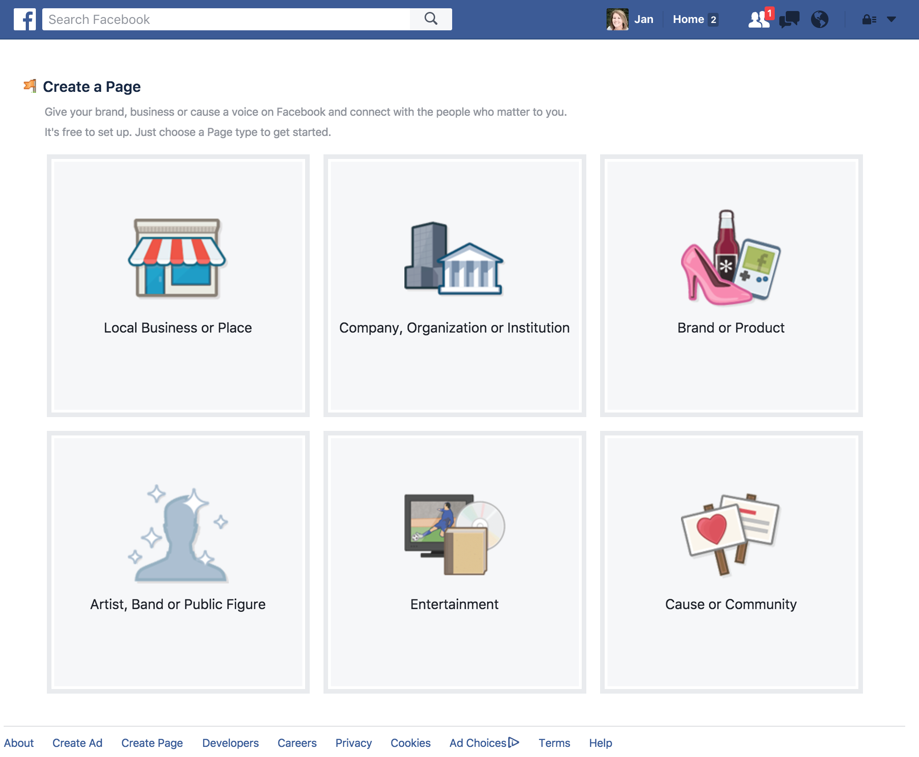

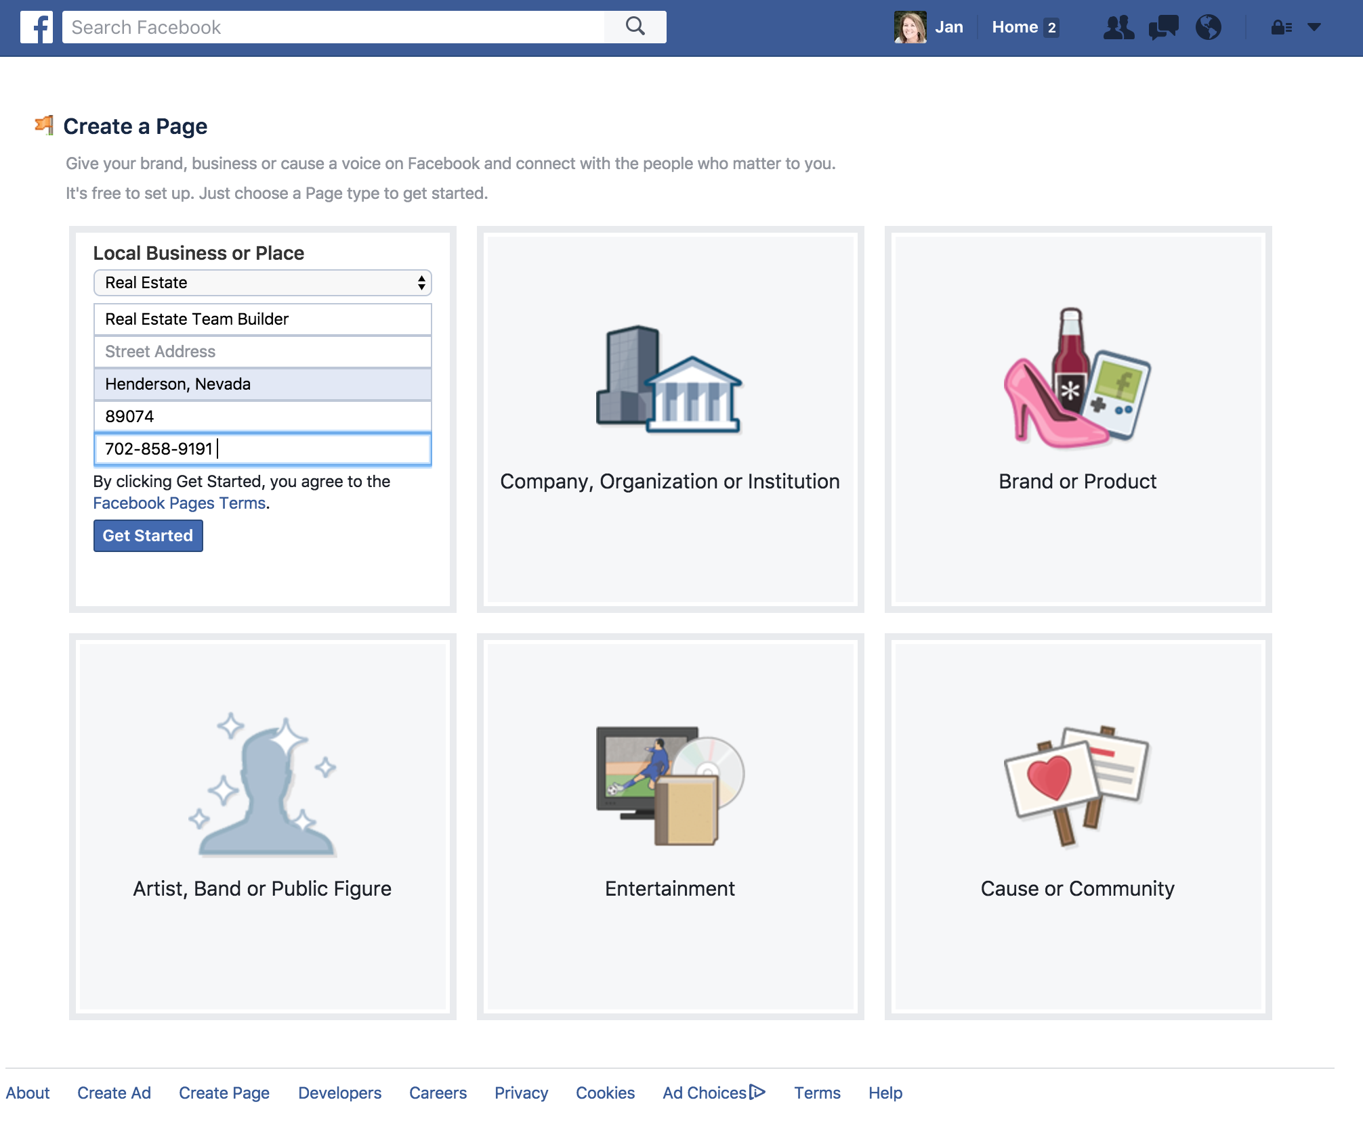
Choose your category (Real Estate) and enter your office address (where you hang your license).
You will have to create your business name here. Think carefully about this. If you have a domain name for a website already, we suggest using the same thing so branding yourself will be much easier in the future.

(Avoid using “REALTOR” with any other adjective or descriptor phrase as it is not compliant with NAR rules. And do not use the company name by itself.)

After all the basic information is input then click on Get Started.

Set Up “Your Page”

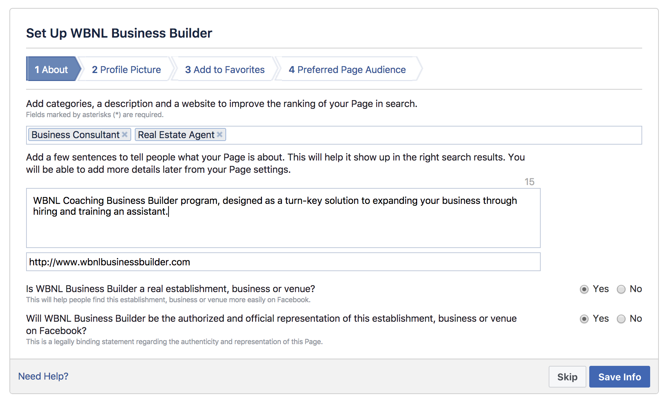

1. Complete the ABOUT section
- Add categories to help people find your page
- Add a short but effective description – who you are and what services do you offer
- Add the URL to your primary website or where you want to drive traffic
- Now select your Facebook page URL. Think branding, name of your page or even your name with a real estate niche or keyword
- Select yes for the final two questions

2. Profile Picture – This can be your professional headshot or an approved logo
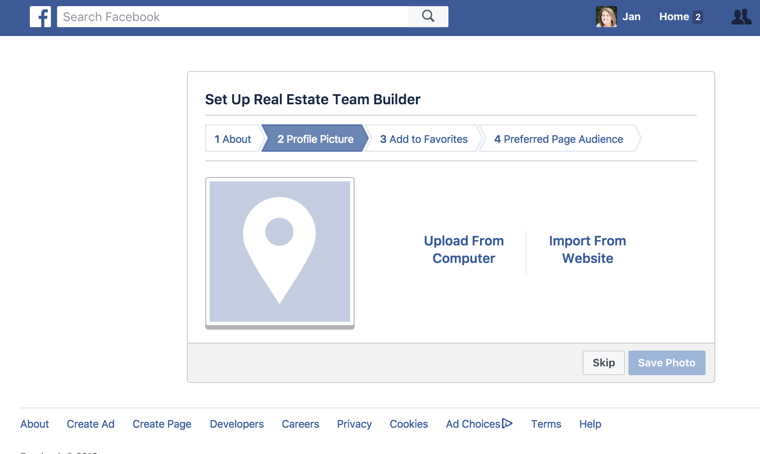

3. Add to Favorites – This will add a shortcut on your news feed so you get to your page easily.
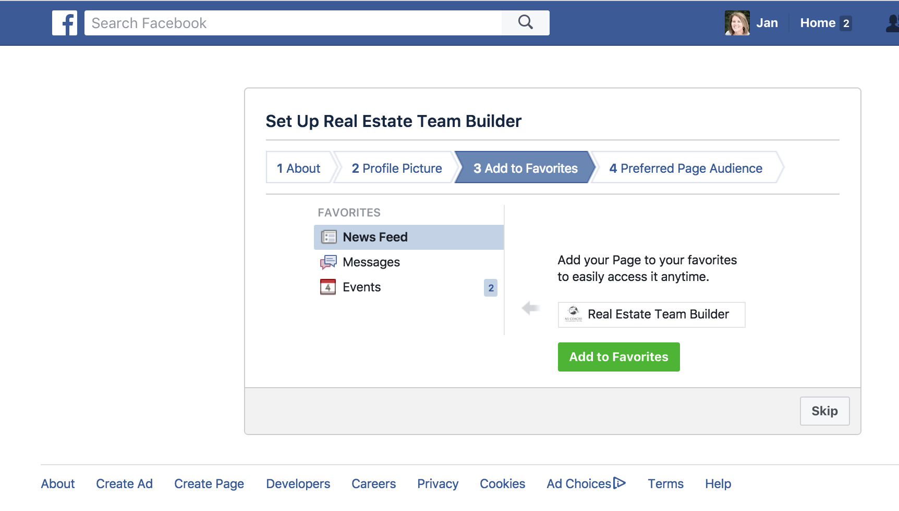
4. Preferred Audience Page – Complete this part with your target audience in mind.
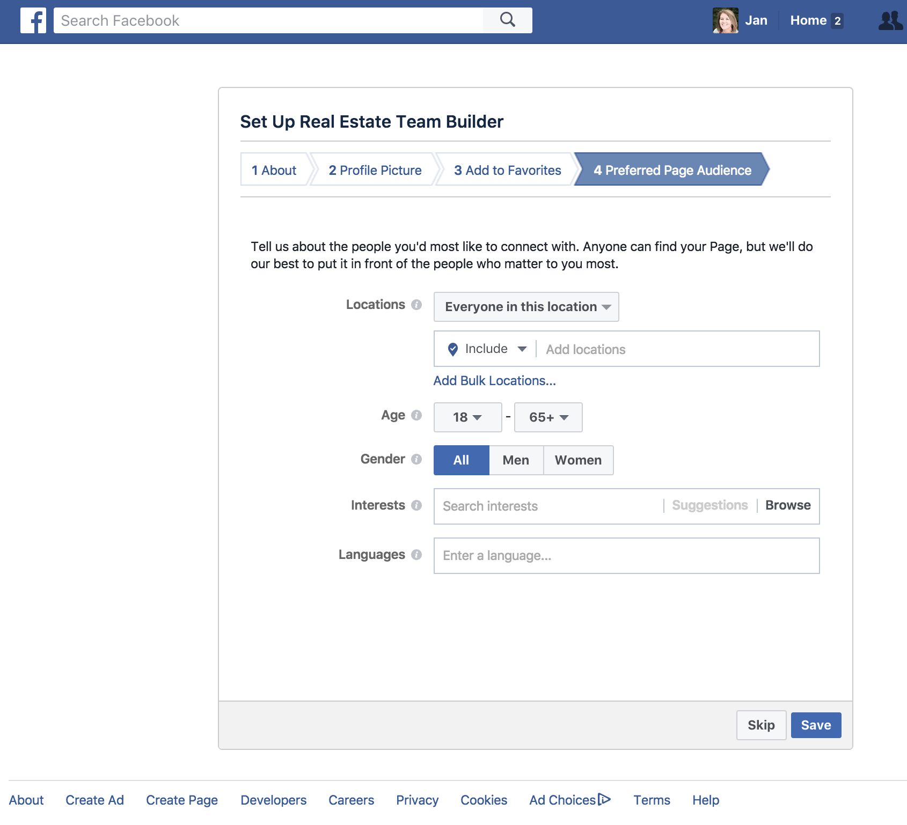
Add a COVER
Make sure the cover photo is properly branded with the TBRG and ROG logos. Your page will not be compliant without both of them.

We have created several branded Team Facebook Covers for you to use. Access them here:
http://thebrodkintrainingmethod.com/social-media/
Create Your CTA Button

We recommend choosing one of the options in the “Get in Touch with Us” section

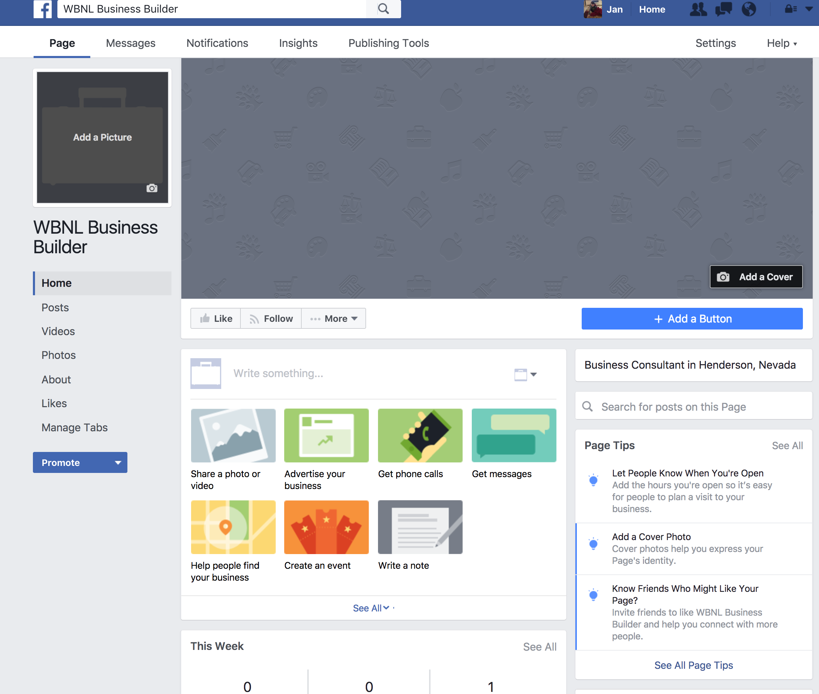

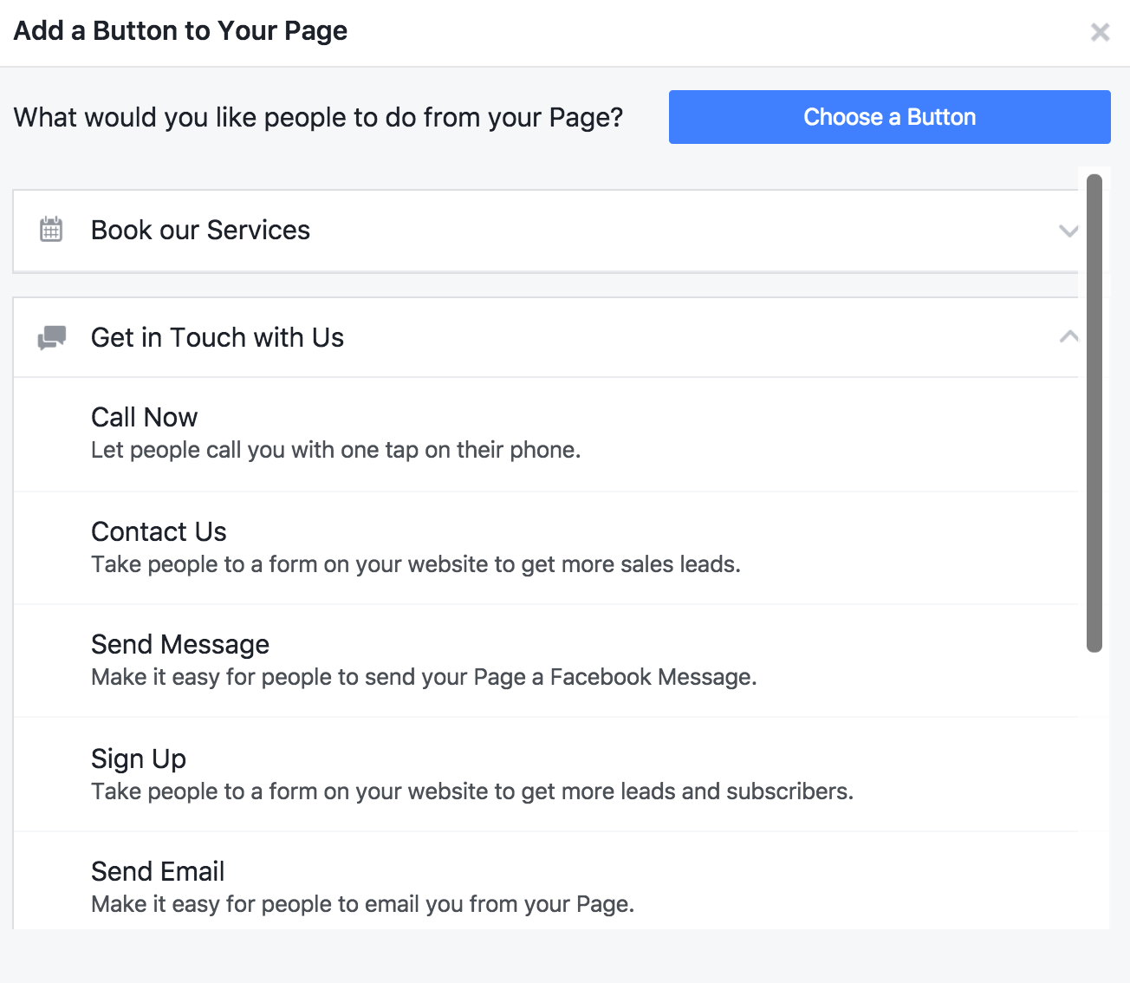

Start Posting & Updating!
Now that your page is setup you can begin posting things for everyone to see. The following are different things you can post on a business page.
Status- this is the same as on your personal profile. You can enter text or share links in the status box and post it to your page wall.

Photo/Video- You can upload your own photos and videos here.

Check-in – just like your profile page, you can check-in to a geographical location and post an update
Pin To Top- this is a great feature that will hold a specific post at the top of your page. As you continue to post new things on your page, all previous posts will keep moving further down on the timeline. If there is something specific, such as a video or perhaps a promotional photo, you would like to keep at the top of the page you can click on the little down arrow in the top right corner of the post and click ‘pin to top’. That will hold that post at the top until you change it. You can also only have one thing pinned to the top at a time.
Create Events – Consider creating an event for your Open Houses and inviting your friends via Facebook.

Schedule Posts
Scheduling posts is a very convenient function on Facebook pages. Since you should be consistently posting at least once per day on Facebook sometimes it can be hard to stay on top of your social media marketing.
To schedule a post:
- Instead of clicking on the Publish button you will click on the triangle on the right side of the Publish button and select schedule.
- You can put the date and time you would like to schedule the post.
- You can do this for as many posts as you would like so you can post far in the future as well.

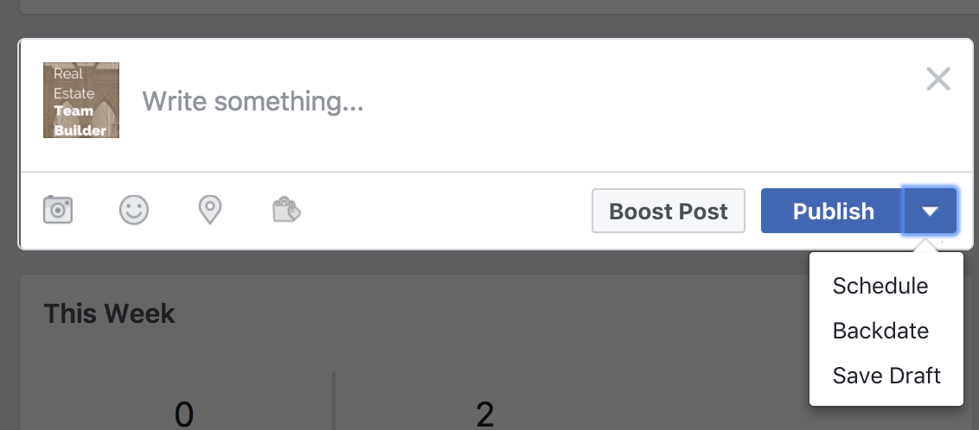

Sharing posts
If you see something you like and would like to share it to your page you can click on the share button under the post.

The share link has several options:
- Share Now (Friends) – will go to your profile
- Share … let’s you add your own comment/content and then select where to share it (your profile, a group or pages you manage)
- Send as Message
- Share on a Friend’s Timeline
- Share to a Page

Getting ‘Likes’ for your page
Invite friend to like your page

- Under the cover photo you will see three buttons on the right.
- Like, Follow and •••. More
- Click on ••• and select invite friends. You can invite each person individually to like your page.
Add your Facebook Page link in all of your marketing:
- Your signature block
- Printed materials
- Business Card
- Online – websites, other social media platforms, blog
Page Settings

There are a ton of settings to go through and decide what is best for you and your business.

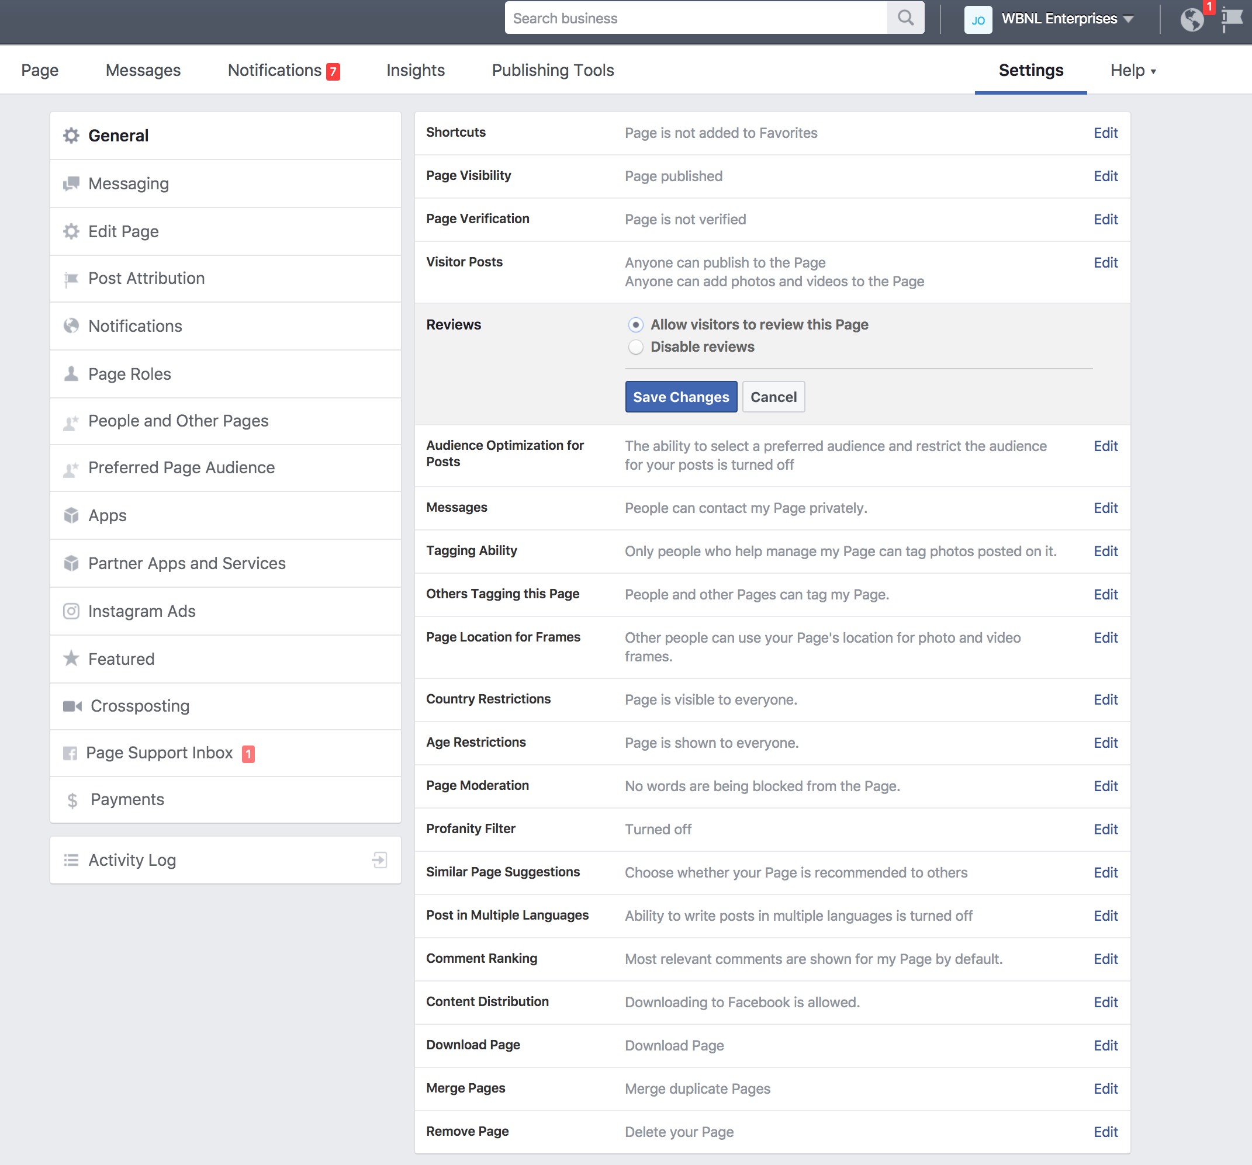

Other Tips

Reviews
- As with anything reviews as a Realtor will help you boost your credibility. There is a review section on every Facebook business page so we recommend inviting all of your past clients to write a positive review about your services.
- Make sure you have Reviews Turned on in Your Settings

Engagement is key!!!
- Post content you think will get the most engagement among your followers. The more likes, comments and shares your posts get the more people it will reach.
- Tag people in posts- If you tag people in your posts that post will appear in their newsfeeds and not only will they see it, their friends will also see it.
Insights
- At the top of the page you can see the ‘Insights’ tab. If you click on that you can check the stats of your page. This is convenient for finding out which type of posts earn you the most engagement from your followers. Obviously, if you see something doing well and receiving a lot of action you may want to consider posting more content like that.
Advertising on Facebook
- Boosting posts is a good place to start and test advertising
- This is a paid form of advertisement you can do on Facebook.
- Choose which post you prefer to advertise on your business page timeline.
- Underneath the post click on ‘Boost Post’
- Choose your target audience, price point and how long you would like to boost it for.
- The boosted post will appear in the newsfeed of your targeted audience.

