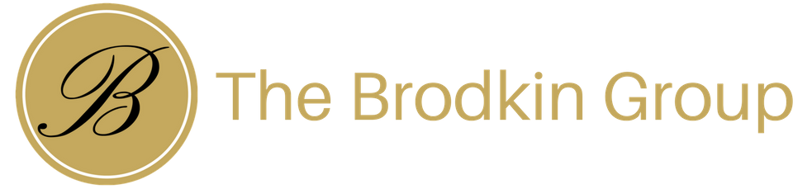

The Brodkin Group Honors Our Heroes

The Brodkin Group, a community-minded real estate company, and leader in Southern Nevada, is proud to announce the launch of an initiative to give back and say “Thank You” to the local heroes that surround us every day!

“Our business touches every segment of society,” says Rich Brodkin, Founder and CEO of The Brodkin Group,” We are passionate about making a difference in their lives when and wherever we can. The Honoring Our Heroes initiative was designed to ease the financial side of the real estate transaction so that we can help get them into their dream home.”

The Brodkin Group will contribute $1,000 toward the closing costs when participants sell or purchase a home with one of The Brodkin Group real estate sales professionals. *

If you are Active Military or a Veteran, Law Enforcement, Firefighter, First Responder, in the Medical field, or Education, you are eligible to enroll. Go to www.TheBrodkinGroup.com to learn more, sign up, and get connected with a Brodkin Group professional today!
*Lender restrictions apply
About The Brodkin Group
In just a few short years, The Brodkin Group has grown to over 150 agents in Southern Nevada , with a closed sales volume of 93.2 million in 2017 – making The Brodkin Group #4 in Closed Transactions and #7 in Closed Volume in the State and #1 in Nevada at Realty ONE Group. Experience The Brodkin Group Difference TODAY! Call us at 702-815-1114 or by email to mailto:admin@TheBrodkinGroup.com

