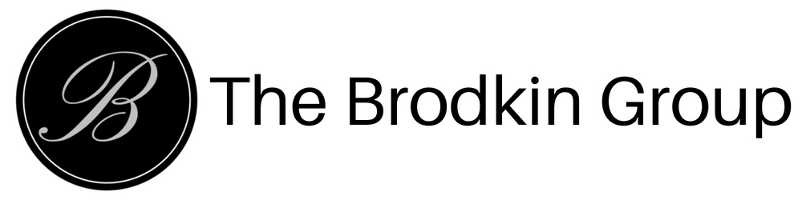

Leads Team Policies & Procedures

Pre-Requisites for Agents On the TBG Leads Team

- Full-time real estate agent with The Brodkin Group, Home Connect America.
- A member in good standing and current with all dues/fees to TBG, the Real Estate Division/DRE, and affiliated Board of REALTORS.
- Complete and submit DISC Profile and Values Reports to Team Manager/Leads Division (www.TonyRobbins/com/ue )
- Minimum of one closed transaction.
- Top Producer user and has completed the Top Producer training.
- Fluent in English or it is primary language. Any additional languages to be noted for potential lead assignment.
- Zillow Profile complete with any client reviews (if applicable). Complete the Zillow leads training.
- All 23 TBTM Modules complete with IGT Checklist Tasks complete for:
  - Module 4 - Lead Generation & Conversion Class
  - Module 5 – Understanding Personality & Communication Styles
  - Module 8 – Buyer Consultation, Showing Properties, Closing the Sale
  - Module 9 – Residential Purchase Agreement
  - Module 10 – Mortgage and Financing
  - Mod 17 – Checklist To Get Paid
  - Mod 23 – Mastering Top Producer 8i
- Team Manager’s written recommendation and acknowledgement of all pre-requisites completed.
- Agree to and acknowledge all Leads Team policies and Procedures by executing the Leads Team Agreement.

Leads Team Orientation & Training Workshop

Workshop to be scheduled monthly or as needed for new team members (live classroom and/or via Webinar)
- Team Policies & Procedures
- Zillow and/or Platform Training (as needed)
- Internet Lead Conversion Training
- Lead Assignment & Follow-up Protocol

